GRANARD MUNICIPAL DISTRICT

Corporate Affairs,
Aras an Chontae,
LONGFOIRT.

19th September 2017.

To: Each Member of Granard Municipal District.

Dear Member,

You are requested to attend Meeting of Granard Municipal District to be held in
Granard Community Library on Tuesday, 26th September 2017 at 3.30 p.m. to transact business, as set out on the Agenda hereunder.

Yours sincerely,
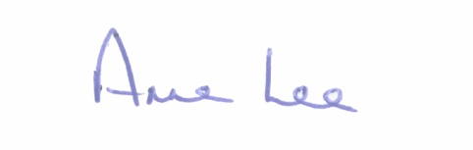

_______________
Anne Lee,
Meetings Administrator.

AGENDA

Prayer before meeting.

1. Confirmation of Minutes of the following meetings of Granard Municipal District -
- Committee Meeting held on the 25th July 2017.
- July Meeting held on the 25th July 2017.
- copies enclosed.

2. Matters arising from Minutes.

3. Presentation by Peter Moran, Moran CCTV, regarding CCTV cameras and attendance by Superintendent Brian Mohan.

4. Area Engineer’s Progress Report.

5. Consideration of the Taking in Charge of “Woodland Park”, Cullyfad,
Co. Longford - details enclosed.

6 Notice of Motion submitted by Councillor P.J. Reilly, as listed hereunder –

“I request an update from Irish Water regarding public sewerage for Abbeylara, as there is a serious issue with pollution in the area.”

7. Correspondence – enclosed.

- Letter dated 4th September 2017 received from Irish Water regarding repair costs for burst mains at Ballywillan, Springtown and Creevy.

8. A.O.B.

